Setting up Application Environment Create Flask Project

|  |  |
| --- | --- |
| Date | 15 November 2022 |
| Team ID | PNT2022TMID29803 |
| Project Name | Skill/Job Recommender Application |

**Step 1.** Install Python latest version from python.org

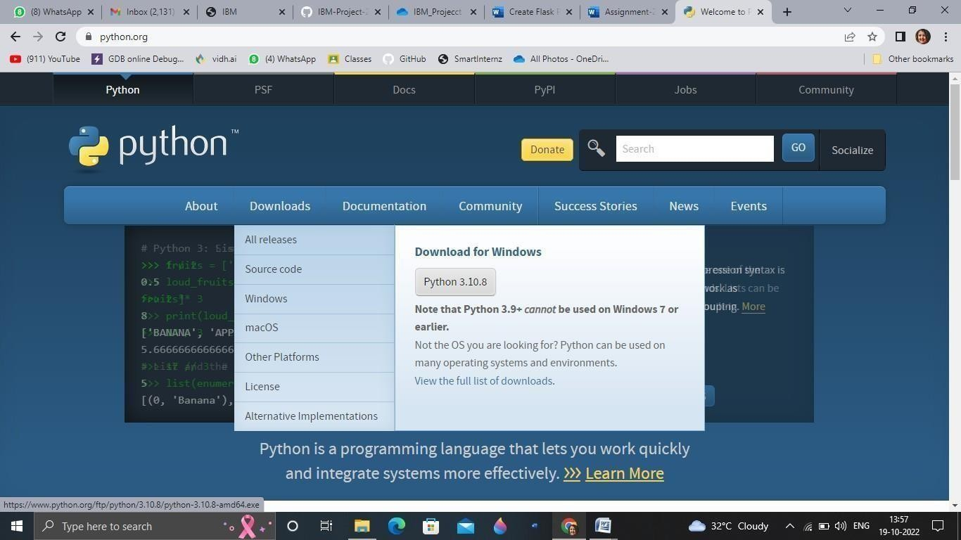

**Step 2**. Download Anaconda from <https://www.anaconda.com/>and install it by running the .exe file

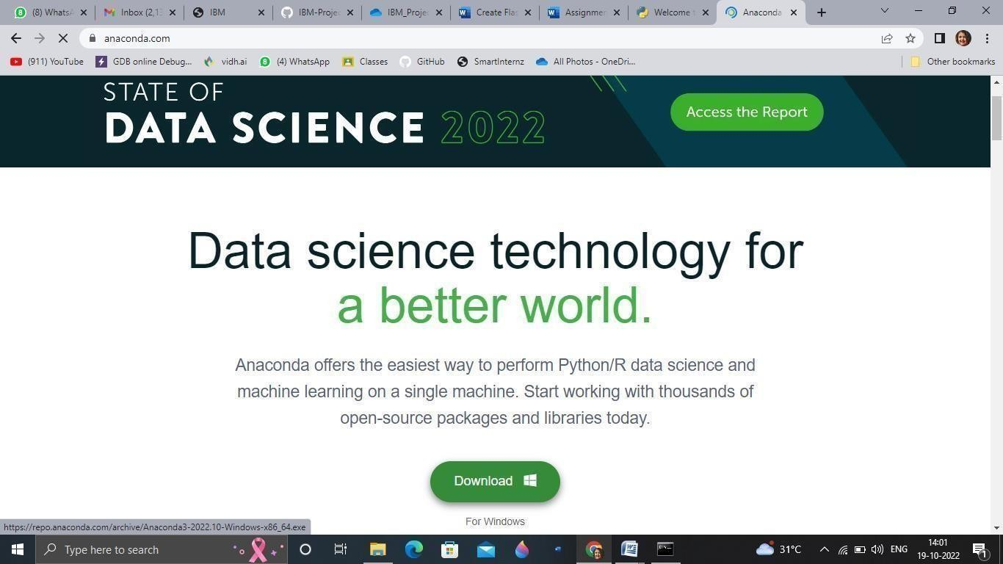

**Step 3**.Install Flask using command pip install flask

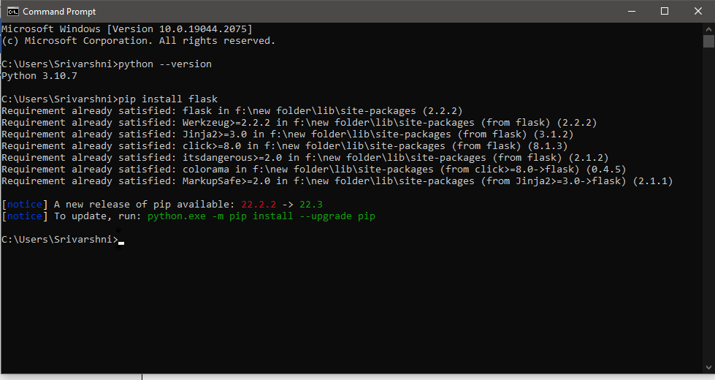

Vishnu M \

**Step 4**.Open a new Python file and start coding

from flask import Flask app = Flask( name ) @app.route('/')

def hello():

return “Hello World”

if name == ' main ': app.run(debug=True)

**Step 5**. Run the Python file using command python filename.py

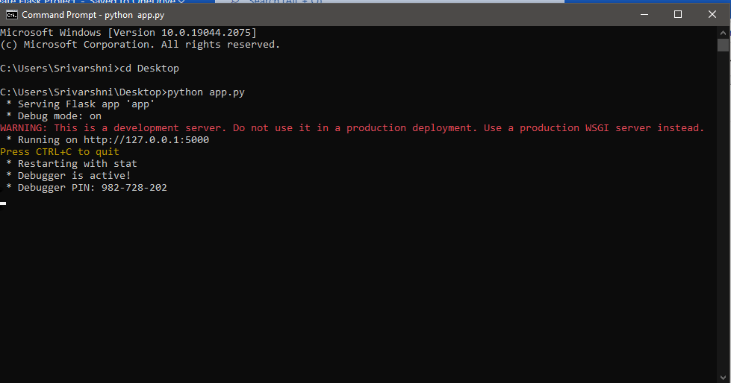

\ Vishnu M

**Step 6**: Open the Ip in browser

